# End-to-End Real Estate Data Project

## Project Overview

This document describes the full lifecycle of a real estate system project starting from data collection and preprocessing, building an operational database, creating a Data Warehouse (DWH), performing ETL processes, analyzing data using Tableau, and finally providing recommendations for data-driven decision-making.

## Project Objectives

1. Collect reliable data from multiple sources.  
2. Build an operational database to store transactional data.  
3. Design a Data Warehouse (DWH) using a Galaxy schema.  
4. Implement ETL processes to load data into the DWH.  
5. Analyze and visualize data through Tableau dashboards.  
6. Provide actionable recommendations for improving data quality and business performance.

## Phase 1: Data Collection

- Web Scraping for listing and property

- Generate data using Python code

Listing: 15,000

Leads: 30,000

Sales: 10,000

Agent: 800

Campaigns: 50 row

## Phase 2: Data Cleaning and Preparation

1.Remove duplicates and Null rows  
2.Standardize formats such as dates, currencies, and measurement units.  
3. Handle missing values

## Phase 3: Operational Database (OLTP)

1. Design an Entity Relationship Diagram (ERD) to represent entities and relationships.  
2. Define data types, primary and foreign keys.  
3. Apply constraints and indexes to improve data integrity and performance.

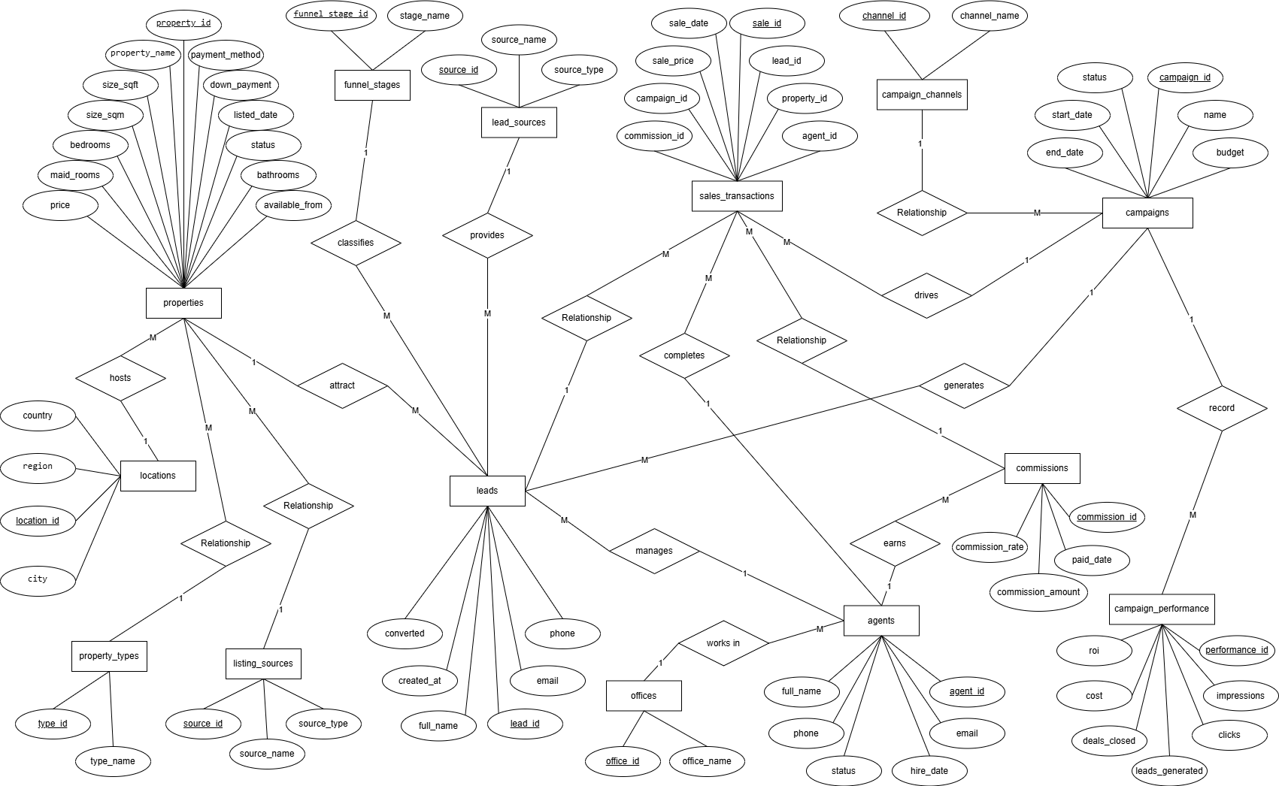

## Phase 4: Data Warehouse (DWH) Modeling

1. Choose a data modeling approach (Galaxy Schema).  
2. Define Fact and Dimension tables with surrogate keys.  
3. Implement Slowly Changing Dimensions (SCD Type 2).  
4. Create a Time Dimension table.

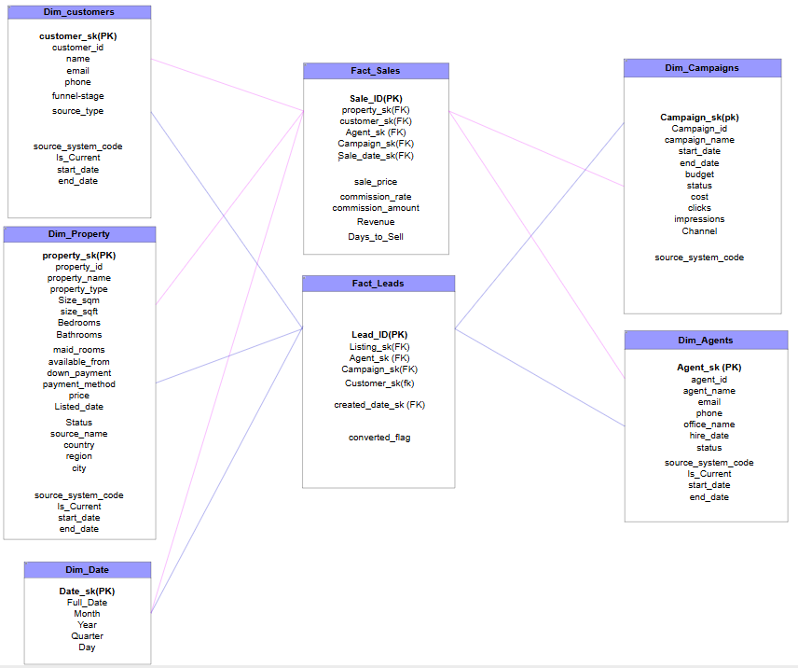

## Create Dimensions and Facts:

-- CUSTOMER DIMENSION

CREATE TABLE Dim_Customers (

Customer_sk INT IDENTITY(1,1) PRIMARY KEY,

Lead_id INT,

Full_Name NVARCHAR(100),

Email NVARCHAR(150),

Phone NVARCHAR(150),

source_type NVARCHAR(50),

stage_name NVARCHAR(50),

Source_System_Code TINYINT NOT NULL

);

-- PROPERTY DIMENSION

CREATE TABLE Dim_Property (

Property_sk INT IDENTITY(1,1) PRIMARY KEY,

Property_id INT,

Property_Name NVARCHAR(150),

Property_Type NVARCHAR(50),

Size_Sqft float,

Size_Sqm float,

Bedrooms tinyint,

Bathrooms int,

Maidroom INT,

Down_Payment float,

Payment_Method NVARCHAR(50),

Price int,

Listed_Date DATE,

Available_From DATE,

Status NVARCHAR(50),

Source_Name NVARCHAR(100),

Country NVARCHAR(100),

Region NVARCHAR(100),

City NVARCHAR(100),

Source_System_Code TINYINT NOT NULL,

Start_Date DATETIME,

End_Date DATETIME,

Is_Current TINYINT NOT NULL

);

-- AGENT DIMENSION

CREATE TABLE Dim_Agents (

Agent_sk INT IDENTITY(1,1) PRIMARY KEY,

Agent_id INT,

Agent_Name NVARCHAR(100),

Email NVARCHAR(150),

Phone NVARCHAR(50),

Office_Name NVARCHAR(100),

Hire_Date DATE,

Status NVARCHAR(50),

Source_System_Code TINYINT NOT NULL,

Start_Date DATETIME,

End_Date DATETIME,

Is_Current TINYINT NOT NULL

);

-- CAMPAIGN DIMENSION

CREATE TABLE Dim_Campaigns (

Campaign_sk INT IDENTITY(1,1) PRIMARY KEY,

Campaign_id INT,

Campaign_Name NVARCHAR(150),

Start_Date DATE,

End_Date DATE,

Budget DECIMAL(15,2),

Cost DECIMAL(15,2),

Impressions INT,

Clicks INT,

Channel NVARCHAR(100),

Status NVARCHAR(50),

Source_System_Code TINYINT NOT NULL,

);

-- FACT LEADS

CREATE TABLE Fact_Leads (

Lead_ID_pk INT IDENTITY(1,1) PRIMARY KEY,

Property_sk INT,

Agent_sk INT,

Campaign_sk INT,

Customer_sk INT,

Created_Date_sk INT,

Converted_Flag BIT

constraint property_fk foreign key(Property_sk) references Dim_Property(Property_sk),

constraint Lead_ID_fk foreign key(Customer_sk) references Dim_Customers(Customer_sk),

constraint agent_fk foreign key(Agent_sk) references Dim_Agents(Agent_sk),

constraint campaign_fk foreign key(Campaign_sk) references Dim_Campaigns(Campaign_sk),

constraint date_fk foreign key(Created_Date_sk) references DimDate(DateSK)

);

-- FACT SALES

CREATE TABLE Fact_Sales (

Sale_ID INT IDENTITY(1,1) PRIMARY KEY,

Property_sk INT,

Customer_sk INT,

Agent_sk INT,

Campaign_sk INT,

Sale_Date_sk INT,

Sale_Price DECIMAL(15,2),

Commission_Rate DECIMAL(5,2),

Commission_Amount DECIMAL(15,2),

Revenue DECIMAL(15,2),

Days_to_Sell INT

constraint sales_property_fk foreign key(Property_sk) references Dim_Property(Property_sk),

constraint sales_customer_fk foreign key(customer_sk) references Dim_Customers(Customer_sk),

constraint sales_agent_fk foreign key(Agent_sk) references Dim_Agents(Agent_sk),

constraint sales_campaign_fk foreign key(Campaign_sk) references Dim_Campaigns(Campaign_sk),

constraint sales_date_fk foreign key(Sale_date_sk) references DimDate(DateSK)

);

## Phase 5: ETL Process

* Create package for each table, each package independently performs the extraction, transformation, and loading processes
* The transformation logic includes data cleaning, field mapping, and enrichment to align with the Data Warehouse (DWH) structure.
* Load processed data into DWH Fact and Dimension tables.

**Customer Dimension**

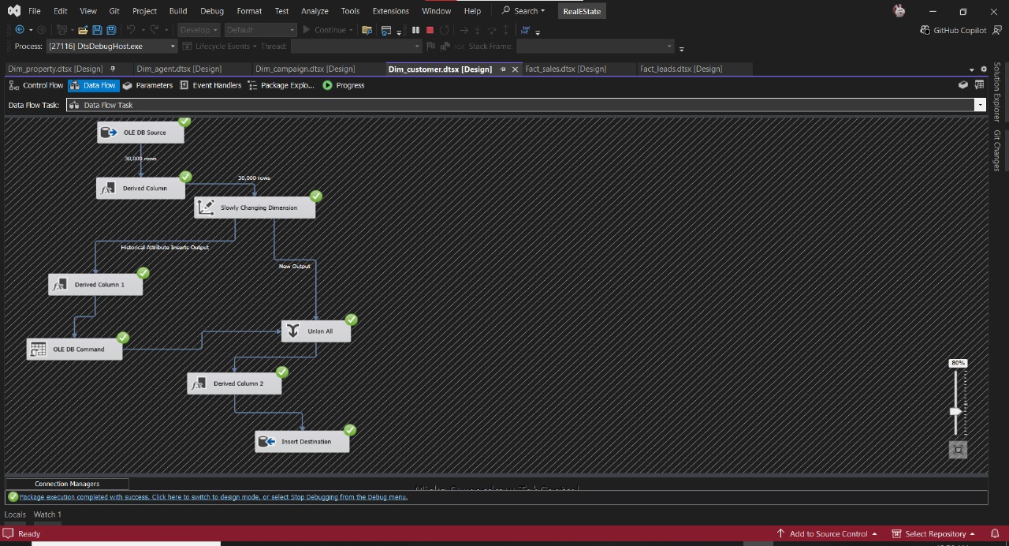

**Fact Sales**

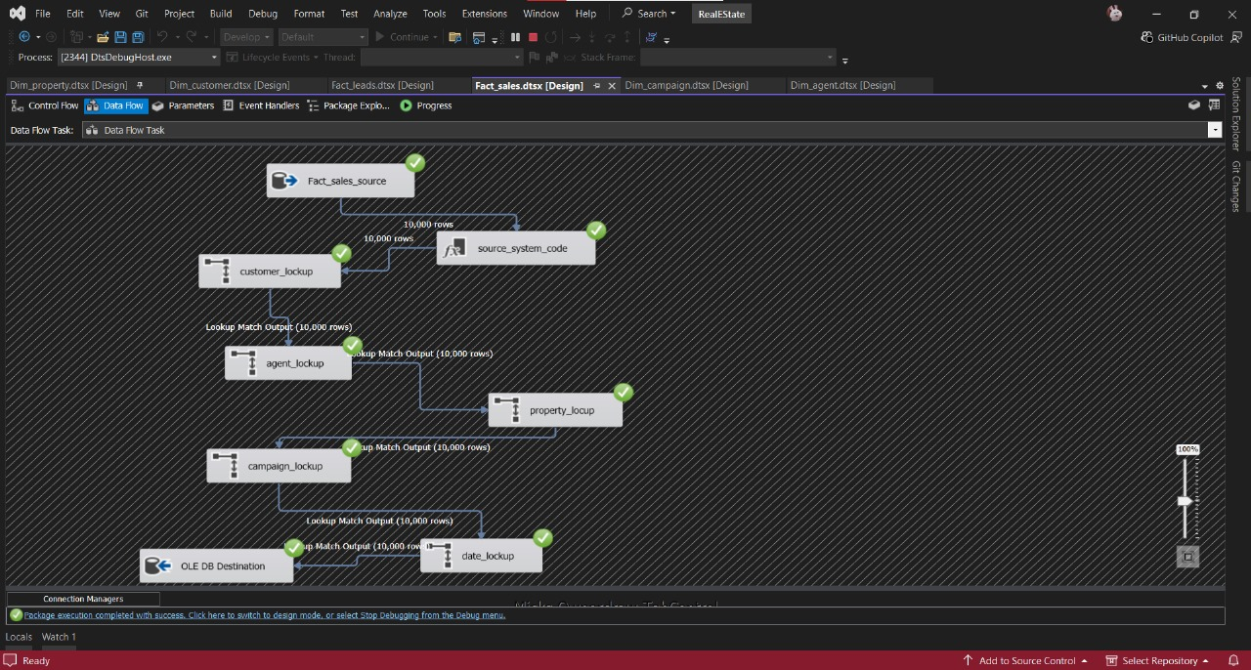

## Phase 6: Analysis Using SQL Queries

-- Property Performance

create view property_KPIs as (

select format(avg(cast(s.sale_price as float)) , 'N0') 'Average Property Value Sold',

avg(case when status='Sold' then datediff(day,listed_date ,sold_date) end) 'Average Time on Market',

count(case when status='Sold' then p.property_id end ) *100 / count(p.property_id) 'Property Occupancy Rate',

count(case when status='Sold' then p.property_id end) 'sold properties',

count(p.property_id) 'No of properties'

from properties p left join sales_transactions s

on p.property_id=s.property_id

)

GO

select * from property_KPIs ;

Go

-- Listings status by Region

create procedure ListingsStatusByRegion

@Status varchar(50)

as

begin

select l.region, count(p.property_id) 'No of Listing listings'

from properties p join locations l

on l.location_id= p.location_id

where p.status= @Status

group by l.region

end;

GO

EXEC ListingsStatusByRegion 'Active' ;

GO

-- Agent performance

-- deals closed per agent (top 5) in a specific date

alter procedure GetTopAgentsByClosedDeals

@target_month int , @target_year int

as

begin

select top 5 a.full_name ,

count(l.lead_id) 'deals closed',

format(avg(st.sale_price), 'N0') 'Average Revenue',

format(avg(c.commission_amount) , 'N0') 'Average Commession'

from agents a join leads l

on l.agent_id=a.agent_id join sales_transactions st

on a.agent_id=st.agent_id join commissions c

on st.commission_id=c.commission_id

where l.converted=1 and month(st.sale_date)= @target_month and year(st.sale_date)=@target_year

group by a.full_name

order by 2 desc

end;

GO

EXEC GetTopAgentsByClosedDeals 9,2024 ;

GO

-- Market insights and pricing distribution

create view Market_insights as(

select loc.region,pt.type_name,

count(st.sale_id) 'sold properties',

format(avg(st.sale_price) , 'N0') 'Average price' ,

format(avg(p.size_sqm) , 'N0') 'Average of Square Meter'

from properties p join sales_transactions st

on st.property_id= p.property_id join property_types pt

on p.type_id=pt.type_id join locations loc

on loc.location_id=p.location_id

where p.status='Sold'

group by loc.region,pt.type_name

);

GO

select * from Market_insights

order by 3 desc

-- Total sales and revenue trends

create view SalesTrends as (

select year(sale_date) 'Year',

month(sale_date) 'month',

count(st.sale_id) Sales,

format(sum(cast(st.sale_price as float)), 'N0') Revenue,

format(sum(cast(st.sale_price as float)-c.commission_amount) , 'N0') Net_Revenue

from sales_transactions st join commissions c

on st.commission_id=c.commission_id

group by year(sale_date), month(sale_date)

);

select * from SalesTrends

order by 1 , 2;

-- Month-over-Month Growth

create procedure MOMGrowth

@year int

as

begin

select [month],

format(Revenue, 'N0') Revenue,

format(Revenue- lag(cast(Revenue as float)) over(order by [month]) , 'N0') MOMGrowth

from(

select month(sale_date) 'month',

sum(cast(sale_price as float)) Revenue

from sales_transactions

where year(sale_date) = @year

group by month(sale_date)

) as Revenue_Growth

end ;

EXEC MOMGrowth 2024;

-- top-performing campaigns

create view CampaignPerformance as(

select c.campaign_id,

c.name,

datediff(day,c.start_date,c.end_date ) campaign_duration,

c.budget,

cp.clicks,

cp.cost,

cp.deals_closed,

cp.leads_generated,

cp.impressions,

cp.roi

from campaigns c join campaign_performance cp

on c.campaign_id=cp.campaign_id

)

select * from CampaignPerformance

-- top-performing offices

create view OfficesPerformance

as(

select o.office_name ,

count(distinct a.agent_id) AgentsCount,

count(l.lead_id) LeadsCount,

count(case when l.converted=1 then lead_id end ) Sales

from offices o join agents a

on a.office_id=o.office_id join leads l

on a.agent_id=l.agent_id

group by o.office_name

) ;

select top 5* from OfficesPerformance

order by Sales desc

-- Number of leads and Conversion_Rate

create function LeadsAndConversion()

returns table

as

return(

select count(lead_id) 'Total Leads Generated',

count(case when converted=1 then lead_id end) *100 / Count(lead_id) Conversion_Rate

from leads l )

;

select * from dbo.LeadsAndConversion()

--Cost per Lead

create function Cost_per_Lead ()

returns nvarchar(50)

as

begin

declare @totalCost float, @TotalLeads int, @CostPerLead nvarchar(50)

set @totalCost =( select sum(cast(cp.cost as float))

from campaigns c join campaign_performance cp

on cp.campaign_id=c.campaign_id ) ;

set @TotalLeads = (select count(lead_id) from leads) ;

set @CostPerLead = @totalCost/@TotalLeads

Return @CostPerLead ;

end ;

select dbo.Cost_per_Lead() as CostPerLead

--Lead Source Effectiveness

create view LeadSourceEffectiveness

as(

select ls.source_name,

cc.channel_name,

count(l.lead_id) 'No Of Leads'

from leads l join campaigns c

on l.campaign_id=c.campaign_id join campaign_channels cc

on c.channel_id=cc.channel_id join properties p

on p.property_id=l.property_id join listing_sources ls

on ls.source_id=p.source_id

group by ls.source_name,cc.channel_name

) ;

select * from LeadSourceEffectiveness ;

-- Average Sales Cycle Duration

create function AvgSalesCycleDuration()

Returns int

as

begin

declare @AvgDuration int

set @AvgDuration= (select avg(datediff(day, l.created_at,st.sale_date) )

from leads l join sales_transactions st

on l.lead_id=st.lead_id)

return @AvgDuration

end ;

select dbo.AvgSalesCycleDuration()

## Phase 7: Tableau Analysis and Dashboards

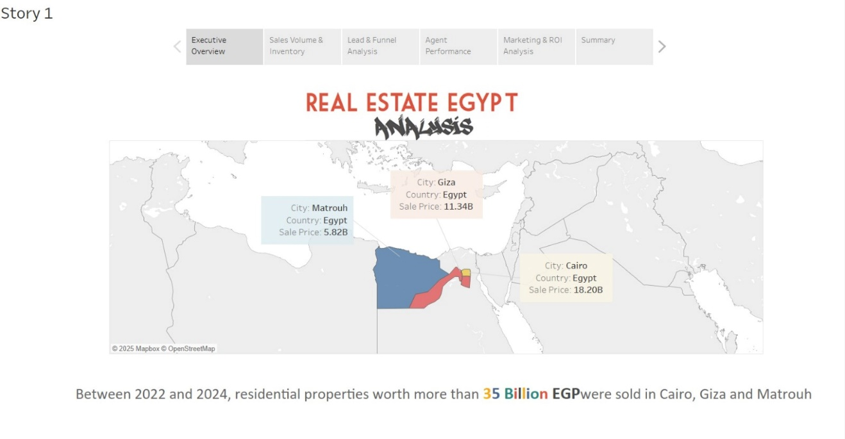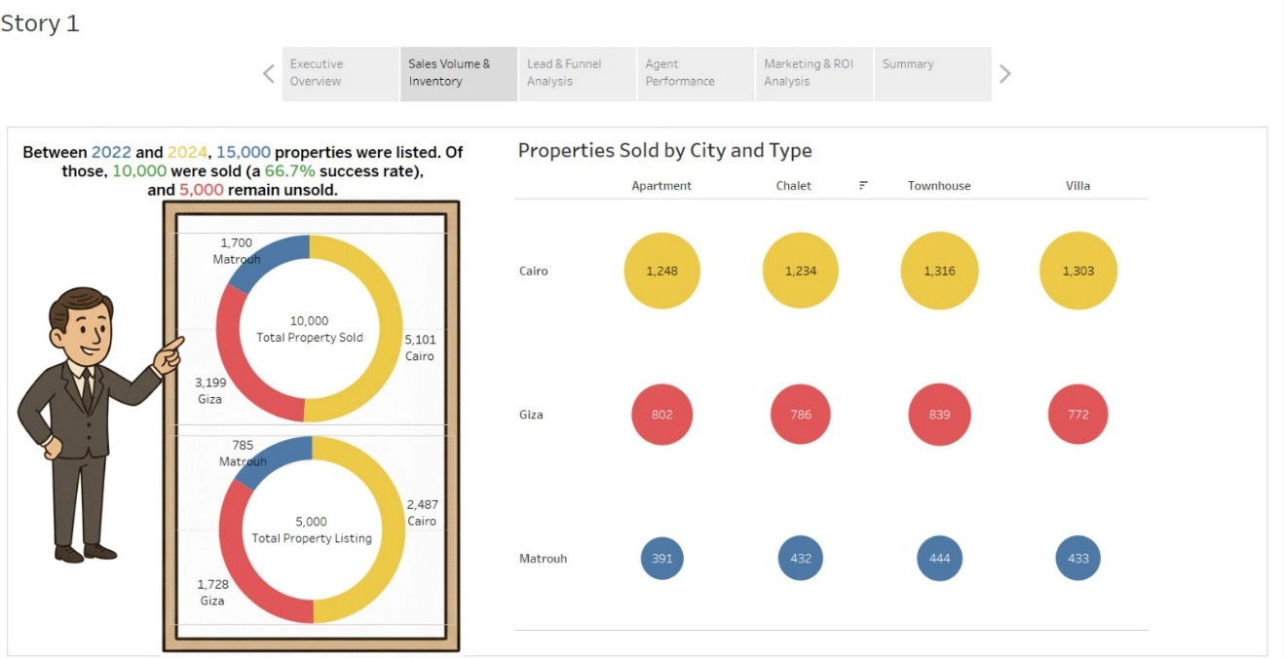

**Insights**

* **Cairo** achieved the highest property sales, representing more than **50% of total sold units**, making it the strongest real estate market.
* **Giza** came second in total sales, while **Matrouh** recorded the lowest but most balanced sales across property types.
* The overall **sales success rate is 66.7%**, with **10,000 sold properties** out of **15,000 listed** between 2022 and 2024.
* **5,000 properties remain unsold**, mostly concentrated in **Cairo and Giza**, indicating a need for better marketing or pricing strategies.
* **Townhouses and Villas** are the most popular property types across all cities

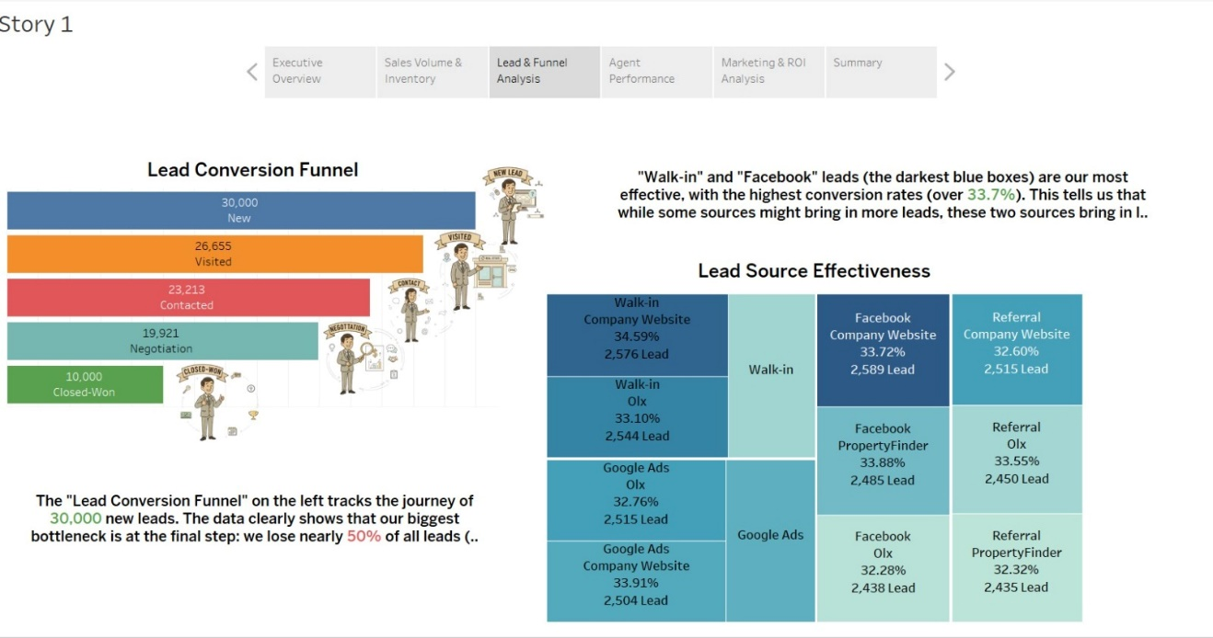

**Insights**

* **30,000 new leads** entered the funnel, but only **10,000 were converted** into closed deals — a **conversion rate of 33.3%**.
* The **biggest drop** in the funnel occurs between **Negotiation (19,921)** and **Closed-Won (10,000)** — showing the need for stronger follow-up and closing strategies.
* **“Walk-in”** and **“Facebook”** leads are the **most effective sources**, each achieving a conversion rate **above 33%**.
* **Referral** and **Google Ads** sources have **slightly lower conversion rates (around 32%)**, meaning they bring good volume but need **better nurturing** to improve closing rates.
* Overall, the data suggests the team should **focus on quality leads rather than quantity**, especially by **investing more in Walk-in and Facebook campaigns**.

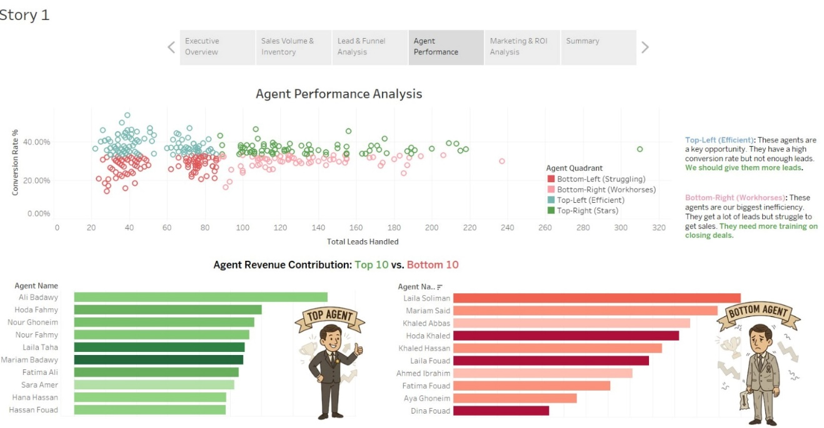

**Insights**

* Top-performing agents **“Stars”** handle a large number of leads and maintain a high conversion rate
* **Top-left quadrant (Efficient agents)** have **strong conversion rates** but **fewer leads**.  
  ➤ They are an **untapped opportunity** — they should be given **more leads** to maximize performance.
* **Bottom-right quadrant (Workhorses)** handle **many leads** but have **low conversion rates**.  
  ➤ They represent **inefficiency** in the sales process and need **additional training in closing deals**.
* **Bottom-left quadrant (Struggling agents)** show both **low leads** and **low conversion rates**, indicating a need for **coaching or reassignment.**
* **Ali Badawy** is the **top-performing agent** in revenue contribution, followed by **Hoda Fahmy** and **Nour Ghoneim**.  
  ➤ These agents consistently convert leads into sales at a high rate.

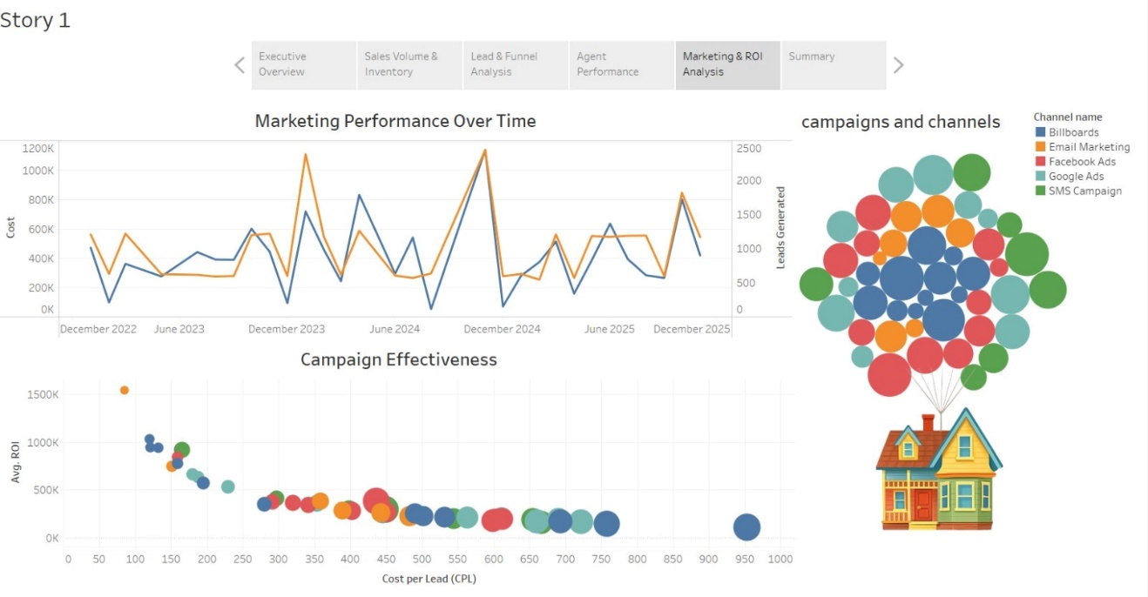

**Insights**

* **Facebook Ads** and **Google Ads** are the **top-performing channels** in generating a high number of leads, while **Billboards** and **Email Marketing** show **lower efficiency** despite high costs
* **SMS Campaigns** and some **Facebook campaigns** provide **the best ROI-to-cost ratio**, meaning they are both **budget-friendly and effective** in converting leads

## Recommendations

* Focus on maintaining strong marketing and promotional efforts in **Cairo and Giza**, as they have the highest sales performance.
* Launch **targeted marketing campaigns in Matrouh** to boost property demand and improve regional sales balance.
* Improve **follow-up strategies** and provide **sales training** to reduce the drop in the **negotiation stage** of the sales funnel.
* **Increase investment** in high-performing lead sources such as **Facebook** and **Walk-in leads**, while **reassessing underperforming channels**.
* **Distribute leads more efficiently** by assigning more to top-performing agents and offering **training to low-performing ones**.
* **Allocate a larger share of the marketing budget** to **digital channels** (Facebook, Google Ads, SMS) with higher ROI.
* **Reduce spending** on low-return traditional channels like **Billboards** and **Email Marketing**.